COINS-Constantine I (306-337), Trier AE 3- GLORIA EXERCITVS, Soldiers with standards

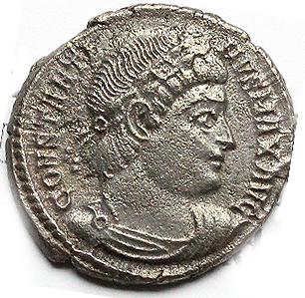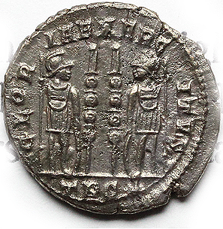

Constantine I (306-337), Trier AE 3- GLORIA EXERCITVS, Soldiers with standards

18 mm 2.64 g